4.8 Centers of Gravity Using Multiple Integrals

Motivation:
Now that we have the notion of double and triple integrals, we can easily get formulas for the center of mass of a lamina which does not have uniform density and center of mass of a three dimensional solid with varying density. We start by looking at the two-dimensional case.

Suppose that a lamina occupies a region D of the xy-plane and its density (in mass per unit area since we view the lamina as two dimensional) at a point in D is given by where is a continuous function on D. The meaning of is where
- is the mass of the portion of the lamina in a small rectangle containing ,
- is the area of the small rectangle,
- and the limit is taken as the dimensions of the rectangle approach 0.

Based upon how is defined, it makes sense intuitively that the mass of the lamina is given by .

Definition: The coordinates of the center of mass of a lamina occupying the region D and having density function are
and

Note: Three double integrals are required to find the center of mass of a lamina.

Note: Intuitively, one can view the double integrals for each coordinate of the center of mass as “weighted averages”.

Note: One will often hear called the moment of the lamina about the x-axis, and will hear called the moment of the lamina about the y-axis.

Example 1: Suppose that a lamina occupies the region and has density function . Find the center of mass of the lamina.

A picture of the region D is:
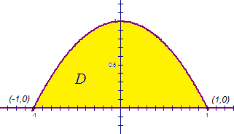

So, we note that the mass of the lamina is

Then, by definition,

Then, by definition,

Thus, the center of mass of the lamina is .

We now explore how to find the center of mass of a three dimensional solid with varying density.
Definition: Suppose that the density function of a solid object that occupies the region E is the continuous function (the unit for this function is mass per unit volume). The center of mass of this object is where , , , and .

Example 2: Find the center of mass of the solid that occupies the region bounded by the graphs of , , , and which has density function .

We will call the solid E. A picture of the solid is:
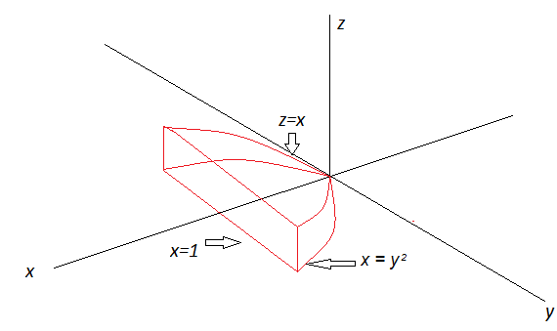
So, we have that . From these inequalities and the above picture, we note that and the projection of E onto the xy-plane is . So, we have that (the integration computation is omitted):
Thus, the answer is that the center of mass of the solid is .

